SECURE DATA STORAGE AND RETRIEVAL FROM THE CLOUD

A Project report submitted in partial fulfilment of the
Requirement for award of the degree of

BACHELOR OF TECHNOLOGY
IN
COMPUTER SCIENCE AND ENGINEERING

Submitted by

G.GURU THEJA G.V.NAGA MANOGNA
(1210312524) (1210312553)

V.SUCHISMITHA V.NIKHIL
(1210312563) (1210312565)
Under the Esteemed Guidance of

Sri R.VENKAT RAO
ASSISTANT PROFESSOR


Department Of Computer Science and Engineering
GITAM Institute of Technology
GITAM UNIVERSITY
VISAKHAPATTNAM- 430045
April -2016


DEPARTMENT OF COMPUTER SCIENCE AND ENGINEERING
GITAM INSTITUTE OF TECHNOLOGY
GITAM UNIVERSITY
(Declared as Deemed-to-be University u/s 3 of UGC Act, 1956)
Accredited by NAAC with ‘A’ Grade
VISAKHAPATNAM-530 045
CERTIFICATE
This is to certify that the project report entitled “SECURE DATA STORAGE AND RETRIEVAL FROM THE CLOUD” is a bonafide work done by G.GURUTHEJA(1210312524), G.V.NAGAMANOGNA(1210312553) and V.SUCHISMITHA(1210312563) and V.NIKHIL(1210312565) in partial fulfillment for the award of the Degree of Bachelor of Technology in Computer Science and Engineering, GITAM Institute of Technology, GITAM University, Visakhapatnam during the year 2015-2016.
INTERNAL GUIDE HEAD OF DEPARTMENT

Sri R.VENKAT RAO Dr P.V.NAGESWARA RAO
Assistant Professor Professor
Department of C.S.E Department of C.S.E
GITAM University GITAM University

DECLARATION

We hereby declare that the project work entitled “Secure Data Storage and Retrieval From the Cloud” is an original and authentic work done in the Dept. of CSE, GITAM Institute of Technology, GITAM University, Rushikonda, Visakhapatnam, under the esteemed guidance of Mr. R.VENKAT RAO, submitted in partial fulfilment of requirements for the award of the Degree of Bachelor of Technology in Computer Science and Engineering during the year 2014-2015. We assure that this project is not submitted in any other university or college for the award of the Degree.

ROLL NO NAMES SIGNATURE
1210312524 G.Guru Theja
1210312553 G.V.Naga Manogna
1210312563 V.SuchiSmitha
1210312565 V.Nikhil

ACKNOWLEDGEMENT
The task of completing a project and submitting a precise report with satisfaction would be incomplete without the mention of a few people who made it possible and whose consistent guidance and encouragement crown all the efforts with success. We express our profound sense of gratitude to our esteemed guide Sri R.Venkat Rao, Assistant Professor, Department of CSE, GIT, GITAM University for his brilliant, gracious guidance and co-operation throughout the work. He spared his valuable time and helped us with keen interest.
We express our deep sense of gratitude to Prof. P.V. Nageswara Rao, Professor &HOD, Department of CSE, GITAM Institute of Technology, GITAM University, Visakhapatnam.
We would like to thank our project coordinator Smt. R.Sireesha, Associate Professor, and Sri K.Srinivas Rao, Associate Professor, Department of CSE, GIT, GITAM University for their helpful suggestions and for taking their time out to ensure that our project is on track.
We would like to thank the Principal Prof. K. Lakshmi Prasad and management of GIT, GITAM University for their constant assistance in the successful completion of our study. We would like to thank the entire faculty for their insights and support during the tenure of the project.
G.Guru Theja (12103125247)
G.V.Naga Manogna (1210312553)
V.SuchiSmitha (1210312563)
V.Nikhil (1210312565)

ABSTRACT

Over the last few years, there has been a drastic change in information technology. This includes the various ways in which files can be shared and stored. Android OS is a relatively new mobile OS which has been steadily taking over more and more market share. Easy to use, easy to develop for, and open-source, it has picked up a following of developers who want to create content for the masses. Cloud computing is publicized as the next major step for all forms of typical information technology use. From businesses, to non-profit organizations, to single users, there seems to be various applications which can use cloud computing to offer better, faster, and smarter computing. This paper aims to combine the two, building a cloud based application for Android, offering users the power of cloud computing in the palm of their hand.

INDEX

1. Introduction 1
1.1 Literature survey 4
2. Problem Statement
2.1 Existing system 7
2.2 Drawbacks of Proposed system 8
2.3 Purpose of Project 9
2.4 Scope 9
2.5 Proposed system 9
3. Requirement Analysis
3.1 Hardware requirements 11
3.2 Software requirements 11
3.3 Functional requirements 12
3.4 Nonfunctional requirements 13
3.5 Modules 15
4. System Implementation
4.1 Android operating system 16
4.2 Java 17
4.3 AES algorithm 23
4.4 Android studio 24
4.5 FTP 25
5. Design Analysis
5.1 System model diagrams 26
5.2 UML diagrams 28
5.3 Sample Code 34
6. Output Screens 50
7. Software Testing 59
7.1 Types of Tests 60
7.2 Test Results 65
8. Conclusions 68
References 70

LIST OF ABBREVATIONS

API Application Programming Interface
AOSP Android Open Source Project
SDK Software Development Kit
ADT Android Development Toolkit
AVD Android Virtual Device
NLP Network Location Provider
UI User Interface
XML Extensible Markup Language
AES Algorithm Encryption Standard
DES Data Encryption Standard
Saas Software as a Service

LIST OF FIGURES
Figure 1 Working of Java 20
Figure 2 Java Platform 21
Figure 3 AES Algorithm 24
Figure 4 System Model 26
Figure 5 Cloud Implementation 27
Figure 6 Modeling a system architecture using views of UML 29
Figure 7 Sequence Diagram 31
Figure 8 Data Flow Diagram 32
Figure 9 Use Case Diagram 33
Figure 10 Sign in Page 50
Figure 11 Email ID Required 51
Figure 12 Incorrect Password 52
Figure 13 Password Too Short 53
Figure 14 Login Successful 54
Figure 15 Files View 55
Figure 16 Upload Files 56
Figure 17 Select Files 57
Figure 18 Upload Completed 58

LIST OF TABLES

Table 0 Signup Page 65
Table 1 Email Id 65
Table 2 Password 66
Table 3 Incorrect Password 66
Table 5 No Network 67
1. INTRODUCTION
File sharing is the practice of distributing or providing access to digitally stored information, such as computer programs, multimedia (audio, images and video), documents, or electronic books. It may be implemented through a variety of ways.
Android is a relatively new mobile operating system developed by Google and the Open Handset Alliance. Officially released in October 2008, it has revolutionized mobile application development due to the fact that it is open source. It allows developers unparalleled freedoms to create varied and interesting applications. Based on the Java programming language, it is touted as being easy to pick up and master, whilst the underlying is a modified Linux kernel.
Some of Android's biggest draws for developers include the relative simplicity of developing using Java syntax, which means quickly producing applications. Also, Android provides easy yet secure access to first and third party applications, allowing deeper integration between components in different programs, and encourages software sharing and reuse.
The user interface can be built quickly and simply through XML or graphically, and once an application has been finished it can be submitted to Android market, a portal through which developers can make their creations available to Android users, either free or for profit.
Cloud computing has been viewed in several forms. There has been no single view that has decidedly become the obvious candidate; however there are some common elements between them all.
The most glaring of these is that it is a form of distributed computing, in that distinctly separate systems link together to form a cloud. Also, there is an idea of on-the-fly scalability, that machines can join and leave the cloud as required.

One definition of cloud computing is that of a pool of computational resources, linked together to provide a greater processing power. These are projects which involve supporters installing software on computers at home, which connect, when idle, to their respective clouds over the internet and compute small parts of complex scientific calculations. Another use of the term is to provide some form of data syncing.

One more idea of cloud computing is that of peer-to-peer systems. This form has been used for many years for file sharing, recently implemented for services such as Skype. These services reduce load on their servers by passing data directly from user to user.

Java is a general-purpose, concurrent, class-based, object-oriented computer programming language that is specifically designed to have as few implementation dependencies as possible. It is intended to let application developers "write once, run anywhere" (WORA), meaning that code that runs on one platform does not need to be recompiled to run on another.
Java applications are typically compiled to bytecode (class file) that can run on any Java virtual machine (JVM) regardless of computer architecture. Java is, as of 2012, one of the most popular programming languages in use, particularly for client-server web applications, with a reported 10 million users. Java was originally developed by James Gosling at Sun Microsystems (which has since merged into Oracle Corporation) and released in 1995 as a core component of Sun Microsystems' Java platform.
The language derives much of its syntax from C and C++, but it has fewer low-level facilities than either of them.
The aim of this project is to design and implement a data backup and storing application for Android based devices. This project will allow multiple users to store and view their files on multiple devices with one application. To this end, files may be uploaded by one user on one device and view on another device, all simplified through an easy to use application on an Android device.
1.1 LITERATURE SURVEY

A rapid Understanding for the cloud computing and control of budgeting, economics and free about very fast accessing in the globally interconnected for distributed network. We can now exploit that power consumption and compute solutions. To survey the cloud computing extremely to change some resolution in the world. The main advantage of cloud computing network to reduce finical, space of development centre and hardware resources. The architecture diagram of the system is given in Fig 1. The application contains two main modules. One is android application installed in smart phone and the second one is cloud application installed in cloud system. The android application is developed using Android SDK. It provides smart phone users, the interface in which user enters the file name and view it. Along with this user can also modify the file and send it back to the cloud. The cloud application gets the input from smart phone to either store it or process it. For file processing in cloud a virtual image of android is set up in the cloud and for storing the data a directory is maintained in the cloud. As an example, in this project face recognition feature has been simulated for demoing offloading. The face recognition logic is set in the cloud space and the result are displayed in android device. This increases the efficiency of the android device by doing by performing the server actions in cloud server based on the request from smart phone the files are transferred to either virtual image or to the directory. The user can also give request through android application to manipulate the files which is already stored in the cloud. The results are displayed back in the android application. Since a virtual image is created in the cloud and all the file processing is happening in the virtual image, the battery backup, processor speed of actual android device is tremendously increased. The application makes all the android data to be stored in to the directory in cloud which makes unlimited storage capacity for android device.
The cloud Environment applications data are accessed millions of Users in multiple devices like android smart phone in your home, The cloud Application server to distribute the data very quickly, undetectable ,virtual memory of cloud environment to solve the problem in physical devices. The application allows user to store the data in a cloud environment and retrieves it and if needed, user can update the file. User interface is designed using android-sdk. User can login to the application with credentials already registered. The credentials are maintained in SQLite Db. Once logged in, the application redirects to search file section, which allows user to enter a filename already there in the cloud and read the file content. The filename entered by the user is appended to an URL which is sends a request to a remote webserver in which turn redirects to the cloud application. The cloud application searches for the filename in the cloud folder and sends its content back to the android application as an HTTP response. The cloud application is a java file which needs to be started before doing the file transfer operation.

2. PROBLEM DEFINITION

2.1 Existing System

The current generation of open source operating systems is not on IBM mainframes or desktops but now days mostly to carry on the android devices in every day and all places. The simplicity of these new environments has lead to new applications and markets and has enabled greater incorporation. This leads to requirement of more storage capacity, processor speed and smaller sizes. It can be achieved by storing data by the smart phone into the cloud. The client can access the storage files in the cloud environment anywhere in the world through the android without any centralized server and access with high speed broad band internet connections. To start with the user opening application and validates the cloud using the authorizations connected with it through android device. Then the name of the file to be used is specified which forms a uniform resource locater to which the filename is appended. This is then send as an HTTP request to a web server, which in -turn redirects to a cloud application which searches the file name in cloud environment.

2.2 Drawbacks of Existing System
The existing methods to store data used by android methods seem simple and easy with no much complexity. However it has some drawbacks.
- Storing important data on a laptop or external hard disk apart from the current device, is using up a lot of space on the back up devices
- For every time, the user has to store data on the external devices, he/she must copy the files from one to another, which is profligate use of time.
- If the external hard disk or the laptop crashes due to any malware activity, then there is a threat to lose the important data also stored as backup on these devices.
- The security of the data on the hard disks cannot be ensured.
- The data stored on these external devices cannot be accessed from every part of the world.

2.3 Purpose of the project:
Providing a solution to stop the loss of data in the mobile if any technical problems arises by adding all the data into the cloud.

2.4 Scope:
- It provides us a platform to backup all the data of the mobile phone.
- The data can be retrieved from the cloud with valid user details.
- The data can be uploaded or downloaded online by logging into the cloud account even though the device is not present.
- Data manipulations and loss of data can be eliminated.
- Data will be secured as the data is stored in the cloud is in encrypted format.

2.5 Proposed System
The content of the file is send back to android device as http response which is then converted to string and displayed in the android device. The user specifies the filename in the android and the cloud will s4.3 Proposed System search the directories for the specified filename. After this, the file will be sent by the cloud to the android. Now through the android, the user can view the contents and do the corresponding updates. By using this application, the pictures can also be transferred from the android to the cloud. The Android application should be developed in the android device and cloud module has to be maintained in the cloud. By developing Cloud connection module and Android application, the user can access the file anywhere from the world through the android and can also transfer the pictures in the android to the cloud. The flexibility of cloud to provide Software as a Service (SaaS) gives wide opportunities to include offloading in the application. A new framework that automatically offloads heavy back-end tasks of a regular standalone Android application to an Android virtual machine in the cloud is also integrated with the application. applications to the cloud saves energy and extend battery lifetime for android users. Since the actual service is happening in virtual smart phone configured in cloud, the battery backup is more thereby saving the energy.

3. REQUIREMENT ANALYSIS
Requirement analysis is an important activity that takes place before building or changing system. It is done in order to understand the problem and the emphasis is on identifying what is needed from the system and how the system in terms of functional and nonfunctional requirements and serves as contractual base between client and developer.
3.1. Hardware Requirements:
A Mobile Phone or a Smart Tablet or device with Android Operating System
3.2. Software Requirements:
- Eclipse IDE
- MySQL
- FTP
- Android Software Development Kit
- JAVA programming language
- JAVA Development Kit
- Android Development Tools(ADT)
- Secure Encryption methods such as AES.
3.3 Functional Requirements:
Inputs:
a. Server:
In this we will enter ip address for client system. In practice, the mechanism can be executed either by the end-user or by a centralized server. In the former case, the source node is responsible for collecting cost reports from individual SRs and computing the path vector and payments. Such an implementation is suitable for an end-user of sufficient power computation capability. A centralized server implementation is more appropriate for resource-constrained users.
b. Operation:
Routers are small physical devices that join multiple networks together. Technically, a router is a Layer3 gateway device, meaning that it connects two or more networks and that the router operates at the network layer of the OSI model. This module consists of a textbox field which is used to enter the destination IP address. After that select the node. Now click on start button in server module. With this the data is transferred to the destination through the selected node. To avoid jamming in that node click on particular avoid jammer node. If we want to know the time elapsed for sending the file click on Time elapsed button in Router .Now go to client module there you will get a message saying that file received.
Output:
By exaggerating its capacity, node may relay a larger fraction of traffic and receive a higher payment, leading to a possibly higher profit. To maintain the overall truthfulness of the mechanism, misreporting of capacity information should be eliminated by design.

3.4 Non Functional Requirements
Performance is measured in terms of the output provided by the application. Requirement specification plays an important part in the analysis of a system. Only when the requirement specifications are properly given, it is possible to design a system, which will fit into required environment. It rests largely in the part of users of the existing system to give the requirement specifications because they are the people who finally use the system.
The requirement specification for any system can be broadly stated as given below:
- The system should be able to interface with the existing system.
- The system should be accurate.
- The system should be better than existing system.

- Portability: It should run on specified platforms successfully. To achieve this we should test the product on all platforms before launching the product. If our project runs successfully on different platforms then our system is portable in nature.
- Reliability: The system should perform its intended functions under specified conditions. If our system satisfies all the specified conditions then it is Reliable in nature.
- Reusability: The system should be extremely reusable as a whole or part. Make the system modularize and make sure that modules are loosely coupled. This project is having reusability nature because we can reuse whole or part of this project on other systems.
- Robustness: The system on the whole should be robust enough to perform well under different circumstances without any inconsistencies.
- Testability: The product of a given development phase should satisfy the conditions imposed at the start of that phase.
- Usability: It should be perfect and comfortable for users to work.
- Security: The system is completely based on the security. This system will provide security base on the password

3.5 Modules:
- Mobile User
- Select files/upload
- View files
.
1. Mobile User Module:
- User can login and logout.
- Add files to upload
2. Select Files/upload
- Users can select files using android api.
- Can upload files in cloud using ftp api
3. View files
Users can view all uploaded files in cloud.
.
4. SYSTEM IMPLEMENTATION
4.1 ANDROID OPERATING SYSTEM
Android is a mobile OS (Operating System ) based on Linux Kernel and currently developed by Google, with a user interface based on direct manipulation. It’s written in c (core), C++, Java. Android is designed primarily for touch screen mobile devices such as smart phones and tablet computers, with specialized user interfaces for television (Android TV), cars (Android Auto) and wrist watches (Android wear). The Operating System uses touch inputs that loosely correspond to real-world actions, like swiping, tapping, pinching and reverse pinching to manipulate on-screen objects and a virtual keyboards.
Despite being primarily designed for touch screen input, it also has been used in games consoles, digital cameras, regular pc’s and other electronics. Android is the most widely used mobile Operating Systems.
The important features are:
a) INTERFACE:
Android defaults uses interface is based on direct manipulation , using touch inputs, that loosely corresponds to real-world actions, like swapping, tapping, pinching and reverse pinching to manipulate onscreen objects and a virtual keyboard.
b) APPLICATION:
Application that extends the functionality of devices are written primarily in the Java programming languages (without the usage “write one, run anywhere” claim of the Java platform) using the Android software development kit (SDK).
c) MEMORY MANAGEMENT:
Since android devices are usually battery-powered, android is designed to manage memory (RAM) to keep power consumption at a minimum, in contact to desk top operating system which generally assumes they are connect to unlimited main electricity.
4.2 JAVA:
Java has been around since 1991, developed by a small team of Sun Microsystems developers in a project originally called the Green project. The intent of the project was to develop a platform-independent software technology that would be used in the consumer electronics industry. The language that the team created was originally called Oak.
The first implementation of Oak was in a PDA-type device called Star Seven (*7) that consisted of the Oak language, an operating system called GreenOS, a user interface, and hardware. The name *7 was derived from the telephone sequence that was used in the team's office and that was dialed in order to answer any ringing telephone from any other phone in the office.
Around the time the First Person project was floundering in consumer electronics, a new craze was gaining momentum in America; the craze was called "Web surfing." The World Wide Web, a name applied to the Internet's millions of linked HTML documents was suddenly becoming popular for use by the masses. The reason for this was the introduction of a graphical Web browser called Mosaic, developed by ncSA. The browser simplified Web browsing by combining text and graphics into a single interface to eliminate the need for users to learn many confusing UNIX and DOS commands. Navigating around the Web was much easier using Mosaic.
It has only been since 1994 that Oak technology has been applied to the Web. In 1994, two Sun developers created the first version of Hot Java, and then called Web Runner, which is a graphical browser for the Web that exists today. The browser was coded entirely in the Oak language, by this time called Java. Soon after, the Java compiler was rewritten in the Java language from its original C code, thus proving that Java could be used effectively as an application language. Sun introduced Java in May 1995 at the Sun World 95 convention. Web surfing has become an enormously popular practice among millions of computer users. Until Java, however, the content of information on the Internet has been a bland series of HTML documents. Web users are hungry for applications that are interactive, that users can execute no matter what hardware or software platform they are using, and that travel across heterogeneous networks and do not spread viruses to their computers. Java can create such applications.
The Java programming language is a high-level language that can be characterized by all of the following buzzwords:
- Simple
- Architecture neutral
- Object oriented
- Portable
- Distributed
- High performance
- Interpreted
- Multithreaded
- Robust
- Dynamic
- Secure
With most programming languages, you either compile or interpret a program so that you can run it on your computer. The Java programming language is unusual in that a program is both compiled and interpreted. With the compiler, first you translate a program into an intermediate language called Java byte codes —the platform-independent codes interpreted by the interpreter on the Java platform. The interpreter parses and runs each Java byte code instruction on the computer. Compilation happens just once; interpretation occurs each time the program is executed. The figure 1 illustrates how this works.
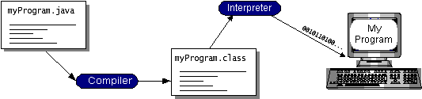
Figure 1: Working Of Java
You can think of Java bytecodes as the machine code instructions for the java virtual machine (Java VM). Every Java interpreter, whether it’s a development tool or a Web browser that can run applets, is an implementation of the Java VM. Java bytecodes help make “write once, run anywhere” possible. You can compile your program into bytecodes on any platform that has a Java compiler. The bytecodes can then be run on any implementation of the Java VM. That means that as long as a computer has a Java VM, the same program written in the Java programming language can run on Windows 2000, a Solaris workstation, or on an iMac.
The Java Platform:
A platform is the hardware or software environment in which a program runs. We’ve already mentioned some of the most popular platforms like Windows 2000, Linux, Solaris, and MacOS. Most platforms can be described as a combination of the operating system and hardware. The Java platform differs from most other platforms in that it’s a software-only platform that runs on top of other hardware-based platforms.
The Java platform has two components:
The java virtual mechine (Java VM)
The java application programming interface (Java API)
You’ve already been introduced to the Java VM. It’s the base for the Java platform and is ported onto various hardware-based platforms.
The Java API is a large collection of ready-made software components that provide many useful capabilities, such as graphical user interface (GUI) widgets. The Java API is grouped into libraries of related classes and interfaces; these libraries are known as packages. The next section, What Can Java Technology Do?, highlights what functionality some of the packages in the Java API provide.
The figure 2 depicts a program that’s running on the Java platform. As the figure shows, the Java API and the virtual machine insulate the program from the hardware.
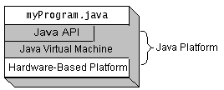
Figure 2: The Java Platform
Native code is code that after you compile it, the compiled code runs on a specific hardware platform. As a platform-independent environment, the Java platform can be a bit slower than native code. However, smart compilers, well-tuned interpreters, and just-in-time bytecode compilers can bring performance close to that of native code without threatening portability.
Working Of Java:
For those who are new to object-oriented programming, the concept of a class will be new to you. Simplistically, a class is the definition for a segment of code that can contain both data and functions. When the interpreter executes a class, it looks for a particular method by the name of main, which will sound familiar to C programmers. The main method is passed as a parameter an array of strings (similar to the argv[] of C), and is declared as a static method.
To output text from the program, iexecute the println method of System. out, which is java’s output stream. UNIX users will appreciate the theory behind such a stream, as it is actually standard output. For those who are instead used to the Wintel platform, it will write the string passed to it to the user’s program.

4.3 ADVANCED ENCRYPTION STANDARD(AES)
The more popular and widely adopted symmetric encryption algorithm likely to be encountered nowadays is the Advanced Encryption Standard (AES). It is found at least six time faster than triple DES.

The features of AES are as follows:
- Symmetric key symmetric block cipher
- 128-bit data, 128/192/256-bit keys
- Stronger and faster than Triple-DES
- Provide full specification and design details
- Software implementable in C and Java

AES performs all its computations on bytes rather than bits. Hence, AES treats the 128 bits of a plaintext block as 16 bytes. These 16 bytes are arranged in four columns and four rows for processing as a matrix.
The 16 input bytes are substituted by looking up a fixed table (S-box) given in design. The result is in a matrix of four rows and four columns.
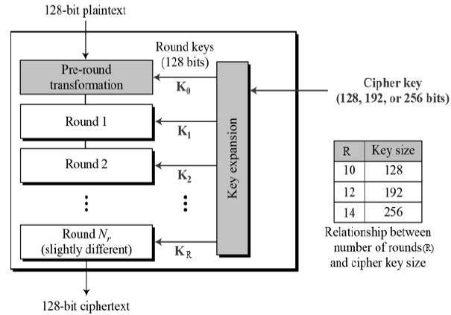
Figure 3: AES Algoritm
4.4 ANDROID STUDIO
Android Studio is the official integrated development environment (IDE) for Android platform development. It was announced on May 16, 2013 at the Google I/O conference. Android Studio is freely available under the Apache License 2.0.
The following features are provided in the current stable version:^{[10][11]}
- Gradle-based build support.
- Android-specific refactoring and quick fixes.
- Lint tools to catch performance, usability, version compatibility and other problems.
- ProGuard integration and app-signing capabilities.
- Template-based wizards to create common Android designs and components.
- A rich layout editor that allows users to drag-and-drop UI components, option to preview layouts on multiple screen configurations.^{[12]}
- Support for building Android Wear apps
- Built-in support for Google Cloud Platform, enabling integration with Google Cloud Messaging and App Engine

4.5 FILE TRANSFER PROTOCOL (FTP)
FTP is the commonly used protocol for exchanging files over the Internet. FTP uses the Internet's TCP/IP protocols to enable data transfer. FTP uses a client-server architecture, often secured with SSL/TLS. FTP promotes sharing of files via remote computers with reliable and efficient data transfer. FTP works in the same way as HTTP for transferring Web pages from a server to a user's browser and SMTP for transferring electronic mail across the Internet in that, like these technologies.
FTP uses a client-server architecture. Users provide authentication using a sign-in protocol, usually a username and password, however some FTP servers may be configured to accept anonymous FTP logins where you don't need to identify yourself before accessing files. Most often, FTP is secured with SSL/TLS.
FTP sessions work in passive or active modes. In active mode, after a client initiates a session via a command channel request, the server initiates a data connection back to the client and begins transferring data. In passive mode, the server instead uses the command channel to send the client the information it needs to open a data channel. Because passive mode has the client initiating all connections, it works well across firewalls and Network Address Translation (NAT) gateways.
5. DESIGN ANALYSIS
5.1 System Model Diagram

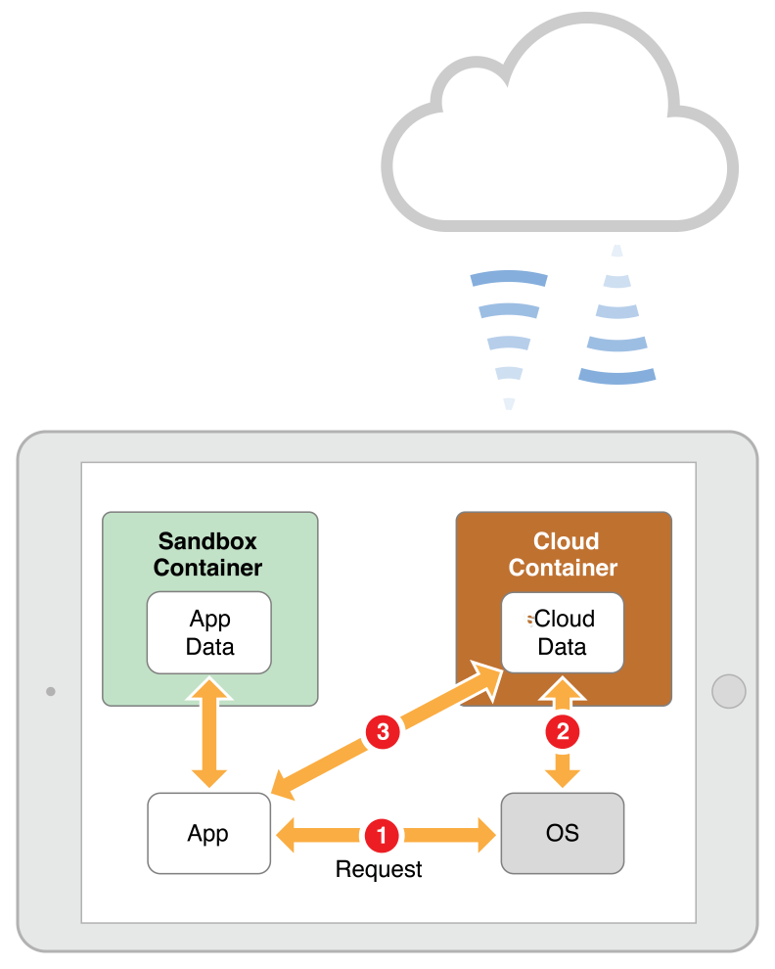

Figure 4: System Model
The Fig.4 shows how the data is accessed from a cloud. The application we create has its content in the sandbox container. When the Operating System calls the application, it makes a call to the sandbox container to access app data. The application or the Operating System can wish to access data from the cloud, which is in cloud container.

The Fig.5 shows how effectively the cloud services can be implemented. The advantage of cloud storage is the data can be accessed from any part of the world without the need of the actual device on which the data exists. With the user authentication(key), the cloud data base can be accessed everywhere securely. This feature of cloud back up makes it the most feasible storage options among all the others.
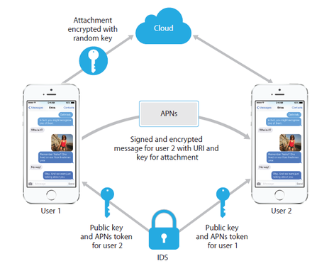
Figure 5: Cloud Implementation
5.2 UML Diagrams:
UML is a method for describing the system architecture in detail using the blueprint.
UML represents a collection of best engineering practices that have proven successful in the modeling of large and complex systems.
UML is a very important part of developing objects oriented software and the software development process.
UML uses mostly graphical notations to express the design of software projects.
Using the UML helps project teams communicate, explore potential designs, and validate the architectural design of the software.
Definition:
UML is a general-purpose visual modeling language that is used to specify, visualize, construct, and document the artifacts of the software system.
UML is a language:
It will provide vocabulary and rules for communications and function on conceptual and physical representation. So it is modeling language.
UML Specifying:
Specifying means building models that are precise, unambiguous and complete. In particular, the UML address the specification of all the important analysis, design and implementation decisions that must be made in developing and displaying a software intensive system.
UML Visualization:
The UML includes both graphical and textual representation. It makes easy to visualize the system and for better understanding.
UML Constructing:
UML models can be directly connected to a variety of programming languages and it is sufficiently expressive and free from any ambiguity to permit the direct execution of models.
UML Documenting:
UML provides variety of documents in addition raw executable codes.
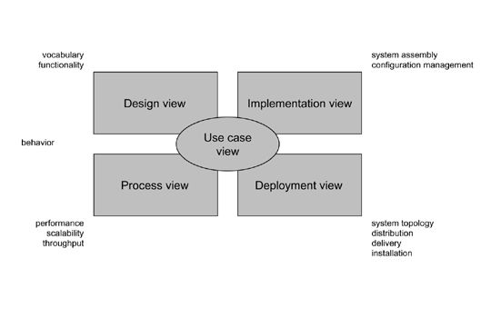
Figure 6: Modeling a System Architecture using views of UML
The use case view of a system encompasses the use cases that describe the behavior of the system as seen by its end users, analysts, and testers.
The design view of a system encompasses the classes, interfaces, and collaborations that form the vocabulary of the problem and its solution.
The process view of a system encompasses the threads and processes that form the system's concurrency and synchronization mechanisms.
The implementation view of a system encompasses the components and files that are used to assemble and release the physical system.
The deployment view of a system encompasses the nodes that form the system's hardware topology on which the system executes.

5.2.1 Sequence Diagram

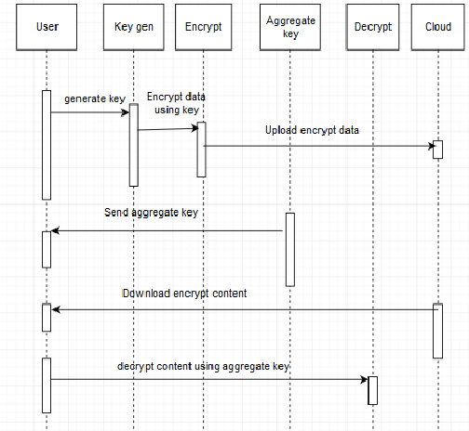
Figure 7: Sequence Digram

The above sequence the sequence in which the application executes. When the user has the access to application, a key is generated which is encrypted and the encrypted data is stored in the cloud. An aggregate key is generated with which the user can decrypt any data that is downloaded from the cloud.

5.2.2 Data Flow Diagram

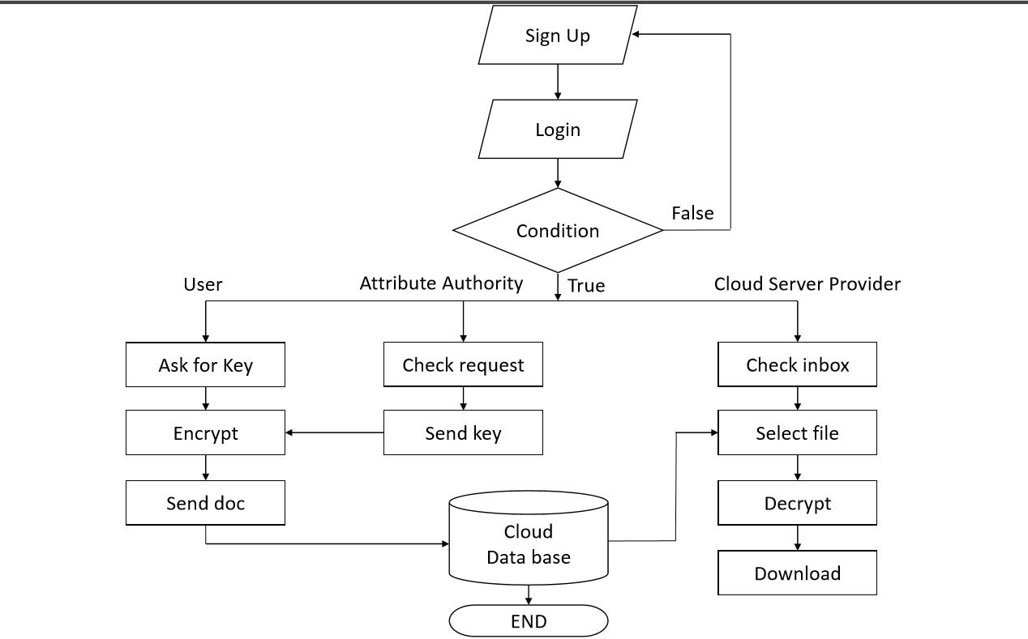
Figure 8: Data Flow Diagram

The above diagram shows the data flow in the application. The application starts with a signup/login page where once the login fails in case of incorrect id or password, the condition is returned false and the page goes to the beginning. The procedure of accessing the application and user data steps are described in the figure.
5.2.3 Use Case Diagram

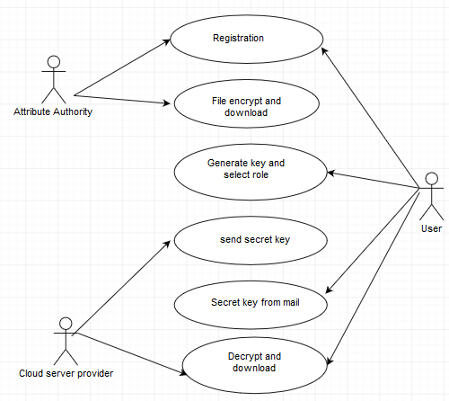

Figure 9: Use Case Diagram
In the above figure, the roles are played by the user, attribute authority and the cloud server provider. The key roles played by the cloud service provider are sending the generated secret key, decrypting and downloading content. The attribute authority is responsible for registration and the file maintenance.

5.3 SAMPLE CODE
Login Activity:
package com.mydrive;
import android.animation.Animator;
import android.animation.AnimatorListenerAdapter;
import android.annotation.TargetApi;
import android.app.Activity;
import android.app.LoaderManager.LoaderCallbacks;
import android.content.ContentResolver;
import android.content.CursorLoader;
import android.content.Intent;
import android.content.Loader;
import android.database.Cursor;
import android.net.Uri;
import android.os.AsyncTask;

import android.os.Build;
import android.os.Bundle;
import android.provider.ContactsContract;
import android.text.TextUtils;
import android.view.KeyEvent;
import android.view.View;
import android.view.View.OnClickListener;
import android.view.inputmethod.EditorInfo;
import android.widget.ArrayAdapter;
import android.widget.AutoCompleteTextView;
import android.widget.Button;
import android.widget.EditText;
import android.widget.TextView;
import android.widget.Toast;
import java.util.ArrayList;
import java.util.List;
/**
* A login screen that offers login via email/password.
*/
public class LoginActivity extends Activity implements LoaderCallbacks<Cursor> {
private static final String[] DUMMY_CREDENTIALS = new String[]{
"foo@example.com:hello", "bar@example.com:world","test@abc.com:test123"
};
/**
* Keep track of the login task to ensure we can cancel it if requested.
private UserLoginTask mAuthTask = null;
// UI references.
private AutoCompleteTextView mEmailView;
private EditText mPasswordView;
private View mProgressView;
private View mLoginFormView;
@Override
protected void onCreate(Bundle savedInstanceState) {
super.onCreate(savedInstanceState);
setContentView(R.layout.activity_login);
// Set up the login form.
mEmailView = (AutoCompleteTextView) findViewById(R.id.email);
populateAutoComplete();
mPasswordView = (EditText) findViewById(R.id.password);
mPasswordView.setOnEditorActionListener(new TextView.OnEditorActionListener() {
@Override
public boolean onEditorAction(TextView textView, int id, KeyEvent keyEvent) {
if (id == R.id.login || id == EditorInfo.IME_NULL) {
attemptLogin();
return true;
}
return false;
}
});

Button mEmailSignInButton = (Button) findViewById(R.id.email_sign_in_button);
mEmailSignInButton.setOnClickListener(new OnClickListener() {
@Override
public void onClick(View view) {
attemptLogin();
}
});
mLoginFormView = findViewById(R.id.login_form);
mProgressView = findViewById(R.id.login_progress);
}
private void populateAutoComplete() {
getLoaderManager().initLoader(0, null, this);
}
/**
* Attempts to sign in or register the account specified by the login form.
* If there are form errors (invalid email, missing fields, etc.), the
* errors are presented and no actual login attempt is made.
*/
public void attemptLogin() {
if (mAuthTask != null) {
return;
}
// Reset errors.
mEmailView.setError(null);
mPasswordView.setError(null);
// Store values at the time of the login attempt.
String email = mEmailView.getText().toString();
String password = mPasswordView.getText().toString();
boolean cancel = false;
View focusView = null;
// Check for a valid password, if the user entered one.
if (!TextUtils.isEmpty(password) && !isPasswordValid(password)) {
mPasswordView.setError(getString(R.string.error_invalid_password));
focusView = mPasswordView;
cancel = true;
}

// Check for a valid email address.
if (TextUtils.isEmpty(email)) {
mEmailView.setError(getString(R.string.error_field_required));
focusView = mEmailView;
cancel = true;
} else if (!isEmailValid(email)) {
mEmailView.setError(getString(R.string.error_invalid_email));
focusView = mEmailView;
cancel = true;
}
if (cancel) {
// There was an error; don't attempt login and focus the first
// form field with an error.
focusView.requestFocus();
} else {
// Show a progress spinner, and kick off a background task to
// perform the user login attempt.
showProgress(true);
mAuthTask = new UserLoginTask(email, password);
mAuthTask.execute((Void) null);
} }

private boolean isEmailValid(String email) {
//TODO: Replace this with your own logic
return email.contains("@");
}
private boolean isPasswordValid(String password) {
//TODO: Replace this with your own logic
return password.length() > 4;
}
/**
* Shows the progress UI and hides the login form.
*/
@TargetApi(Build.VERSION_CODES.HONEYCOMB_MR2)
public void showProgress(final boolean show) {
// On Honeycomb MR2 we have the ViewPropertyAnimator APIs, which allow
// for very easy animations. If available, use these APIs to fade-in
// the progress spinner.
if (Build.VERSION.SDK_INT >= Build.VERSION_CODES.HONEYCOMB_MR2) {
int shortAnimTime = getResources().getInteger(android.R.integer.config_shortAnimTime);

mLoginFormView.setVisibility(show ? View.GONE : View.VISIBLE);
mLoginFormView.animate().setDuration(shortAnimTime).alpha(
show ? 0 : 1).setListener(new AnimatorListenerAdapter() {
@Override
public void onAnimationEnd(Animator animation) {
mLoginFormView.setVisibility(show ? View.GONE : View.VISIBLE);
}
});
mProgressView.setVisibility(show ? View.VISIBLE : View.GONE);
mProgressView.animate().setDuration(shortAnimTime).alpha(
show ? 1 : 0).setListener(new AnimatorListenerAdapter() {
@Override
public void onAnimationEnd(Animator animation) {
mProgressView.setVisibility(show ? View.VISIBLE : View.GONE);
}
});
} else {
// The ViewPropertyAnimator APIs are not available, so simply show
// and hide the relevant UI components.
mProgressView.setVisibility(show ? View.VISIBLE : View.GONE);
mLoginFormView.setVisibility(show ? View.GONE : View.VISIBLE);
}
}

@Override
public Loader<Cursor> onCreateLoader(int i, Bundle bundle) {
return new CursorLoader(this,
// Retrieve data rows for the device user's 'profile' contact.
Uri.withAppendedPath(ContactsContract.Profile.CONTENT_URI,
ContactsContract.Contacts.Data.CONTENT_DIRECTORY), ProfileQuery.PROJECTION,

// Select only email addresses.
ContactsContract.Contacts.Data.MIMETYPE +
" = ?", new String[]{ContactsContract.CommonDataKinds.Email
.CONTENT_ITEM_TYPE},

// Show primary email addresses first. Note that there won't be
// a primary email address if the user hasn't specified one.
ContactsContract.Contacts.Data.IS_PRIMARY + " DESC");
}
@Override
public void onLoadFinished(Loader<Cursor> cursorLoader, Cursor cursor) {
List<String> emails = new ArrayList<String>();
cursor.moveToFirst();
while (!cursor.isAfterLast()) {
emails.add(cursor.getString(ProfileQuery.ADDRESS));
cursor.moveToNext();
}
addEmailsToAutoComplete(emails);
}

@Override
public void onLoaderReset(Loader<Cursor> cursorLoader) {

}

private interface ProfileQuery {
String[] PROJECTION = {
ContactsContract.CommonDataKinds.Email.ADDRESS,
ContactsContract.CommonDataKinds.Email.IS_PRIMARY,
};

int ADDRESS = 0;
int IS_PRIMARY = 1;
}
private void addEmailsToAutoComplete(List<String> emailAddressCollection) {
//Create adapter to tell the AutoCompleteTextView what to show in its dropdown list.
ArrayAdapter<String> adapter =
new ArrayAdapter<String>(LoginActivity.this,
android.R.layout.simple_dropdown_item_1line, emailAddressCollection);
mEmailView.setAdapter(adapter);
}
/**
* Represents an asynchronous login/registration task used to authenticate
* the user.
*/
public class UserLoginTask extends AsyncTask<Void, Void, Boolean> {
private final String mEmail;
private final String mPassword;
UserLoginTask(String email, String password) {
mEmail = email;
mPassword = password;
}
@Override
protected Boolean doInBackground(Void... params) {
try {
// Simulate network access.
Thread.sleep(2000);
} catch (InterruptedException e) {
return false;
}
for (String credential : DUMMY_CREDENTIALS) {
String[] pieces = credential.split(":");
if (pieces[0].equals(mEmail)) {
// Account exists, return true if the password matches.
return pieces[1].equals(mPassword); } }
return true;
}
@Override
protected void onPostExecute(final Boolean success) {
mAuthTask = null;
showProgress(false);
if (success) {
Toast.makeText(getApplicationContext(), "Login Successful", Toast.LENGTH_SHORT).show();
Intent i=new Intent(getApplicationContext(),com.V4Creations.mydrive.view.activity.AndroidServerDirectoryListingMainActivity.class);
startActivity(i);
} else {
mPasswordView.setError(getString(R.string.error_incorrect_password)); mPasswordView.requestFocus();
}
}
@Override
protected void onCancelled() {
mAuthTask = null;
showProgress(false); } } }
Layout.xml
<LinearLayout xmlns:android="http://schemas.android.com/apk/res/android"
xmlns:tools="http://schemas.android.com/tools" android:layout_width="match_parent"
android:layout_height="match_parent" android:gravity="center_horizontal"
android:orientation="vertical" android:paddingBottom="@dimen/activity_vertical_margin"
android:paddingLeft="@dimen/activity_horizontal_margin"
android:paddingRight="@dimen/activity_horizontal_margin"
android:paddingTop="@dimen/activity_vertical_margin"
tools:context="com.mydrive.LoginActivity">
<!-- Login progress -->
<ProgressBar android:id="@+id/login_progress" style="?android:attr/progressBarStyleLarge"
android:layout_width="wrap_content" android:layout_height="wrap_content"
android:layout_marginBottom="8dp" android:visibility="gone" />
<ScrollView android:id="@+id/login_form" android:layout_width="match_parent"
android:layout_height="match_parent"
android:background="#fafbfc">
<LinearLayout android:id="@+id/email_login_form" android:layout_width="match_parent"
android:layout_height="wrap_content" android:orientation="vertical"
android:paddingTop="150dp">
<AutoCompleteTextView android:id="@+id/email" android:layout_width="match_parent"
android:layout_height="wrap_content" android:hint="@string/prompt_email"
android:inputType="textEmailAddress" android:maxLines="1"
android:singleLine="true"
android:textColorHint="#000000" />

<EditText android:id="@+id/password" android:layout_width="match_parent"
android:layout_height="wrap_content" android:hint="@string/prompt_password"
android:imeActionId="@+id/login"
android:imeActionLabel="@string/action_sign_in_short"
android:imeOptions="actionUnspecified" android:inputType="textPassword"
android:maxLines="1" android:singleLine="true"
android:textColorHint="#000000" />
<Button android:id="@+id/email_sign_in_button" style="?android:textAppearanceSmall"
android:layout_width="match_parent" android:layout_height="wrap_content"
android:layout_marginTop="16dp" android:text="@string/action_sign_in"
android:textStyle="bold"
android:textColor="#1b30ce" />
</LinearLayout>
</ScrollView>
</LinearLayout>

6. OUTPUT SCREENS
Fig.10 shows the login page, where user can enter his email and password to sign in.
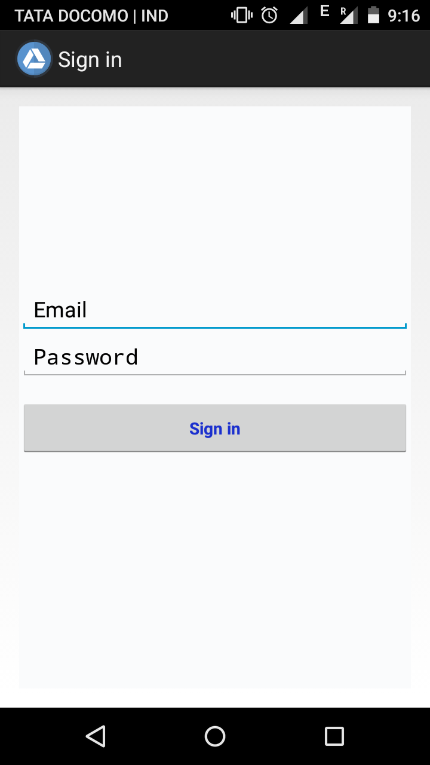

Figure 10: Sign in Page

Fig.11 shows the error message when the email field is empty and user try to sign in.
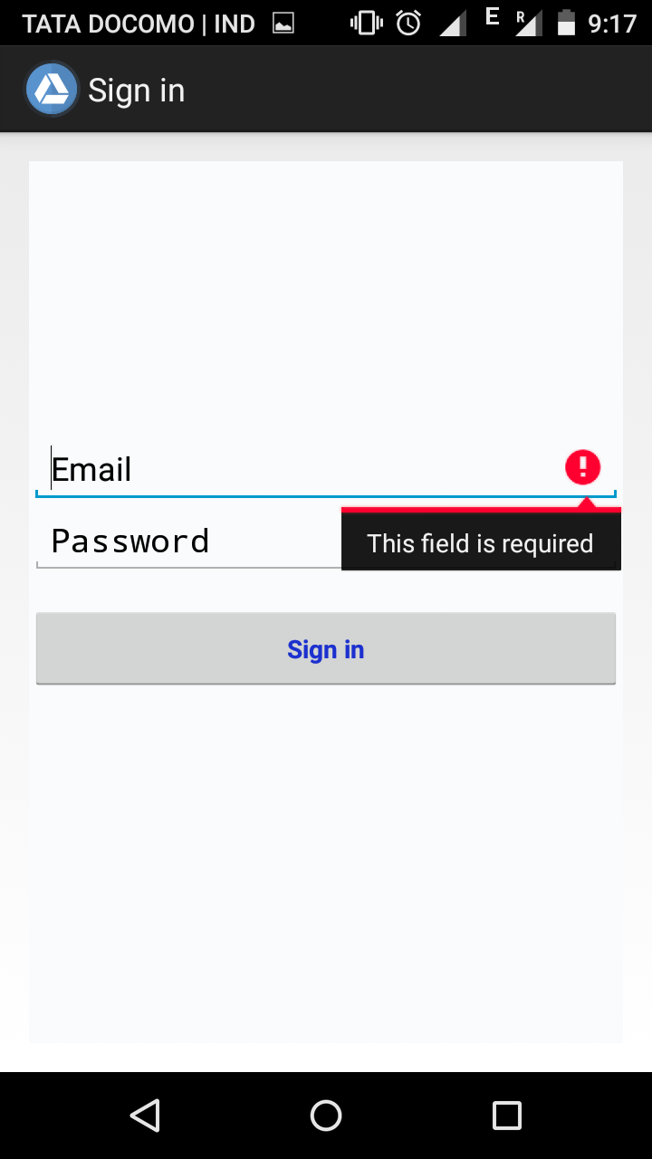
Figure 11: Email ID Required

Fig.12 shows the error message when user try to login with an invalid password.
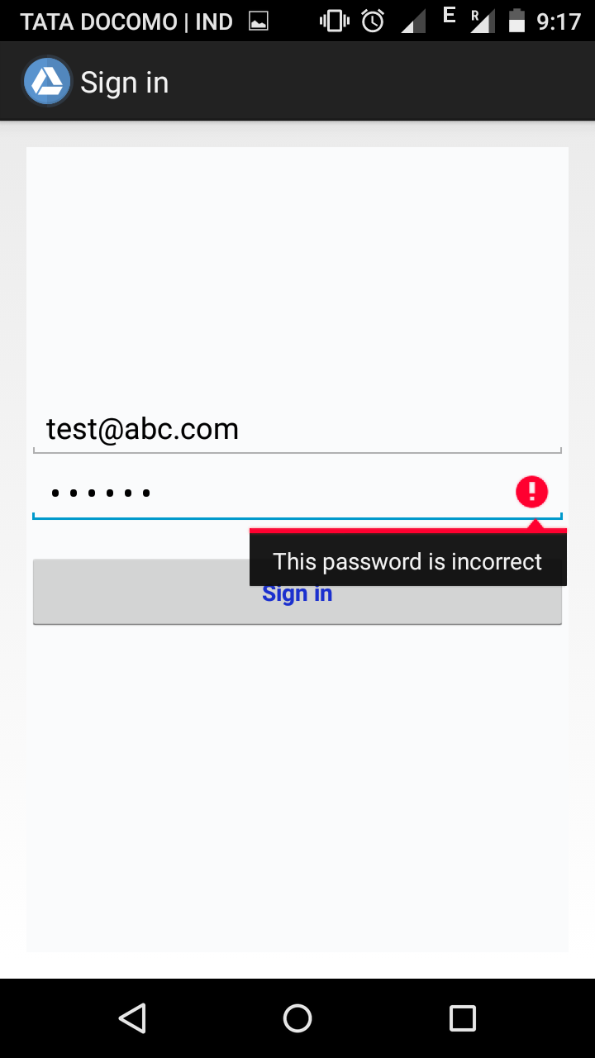
Figure 12: Incorrect Password

Fig.13 shows us the error message when the password entered is too short (i.e. >4 characters).
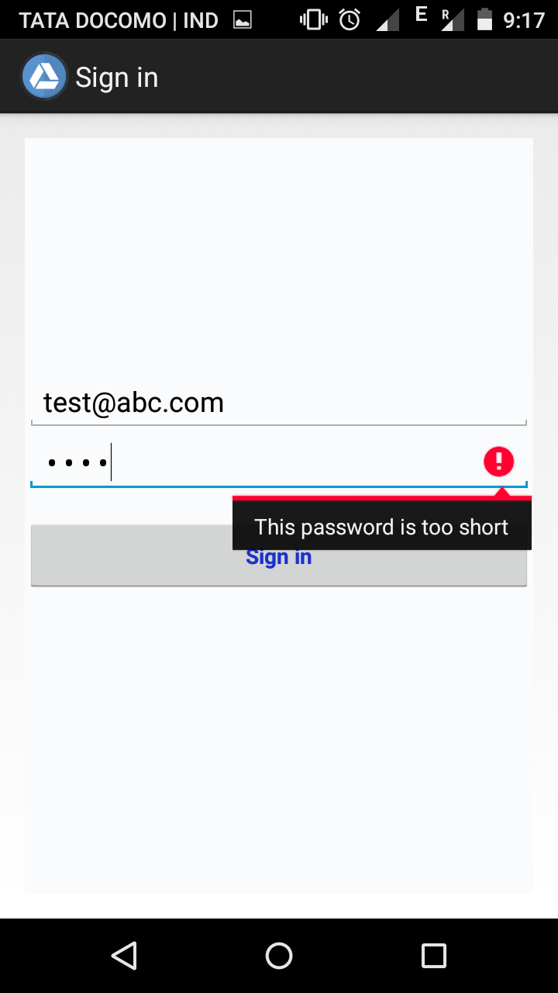
Figure 13: Password too short

Fig.14 shows the Login Successful message when user login in using valid credentials.
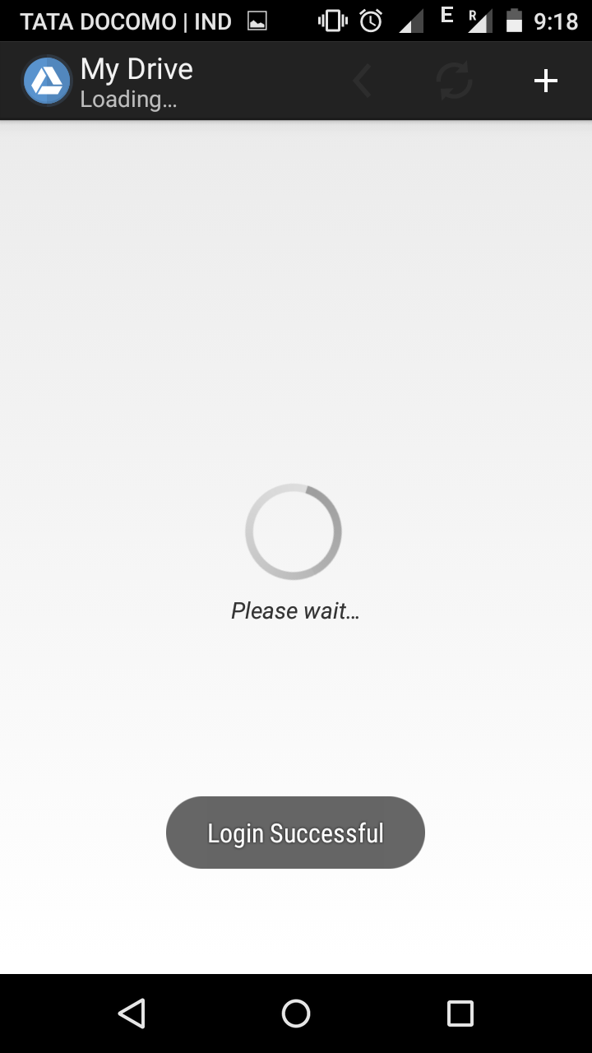
Figure 14: Login Successful

Fig.15 shows the page where user can view all the files.
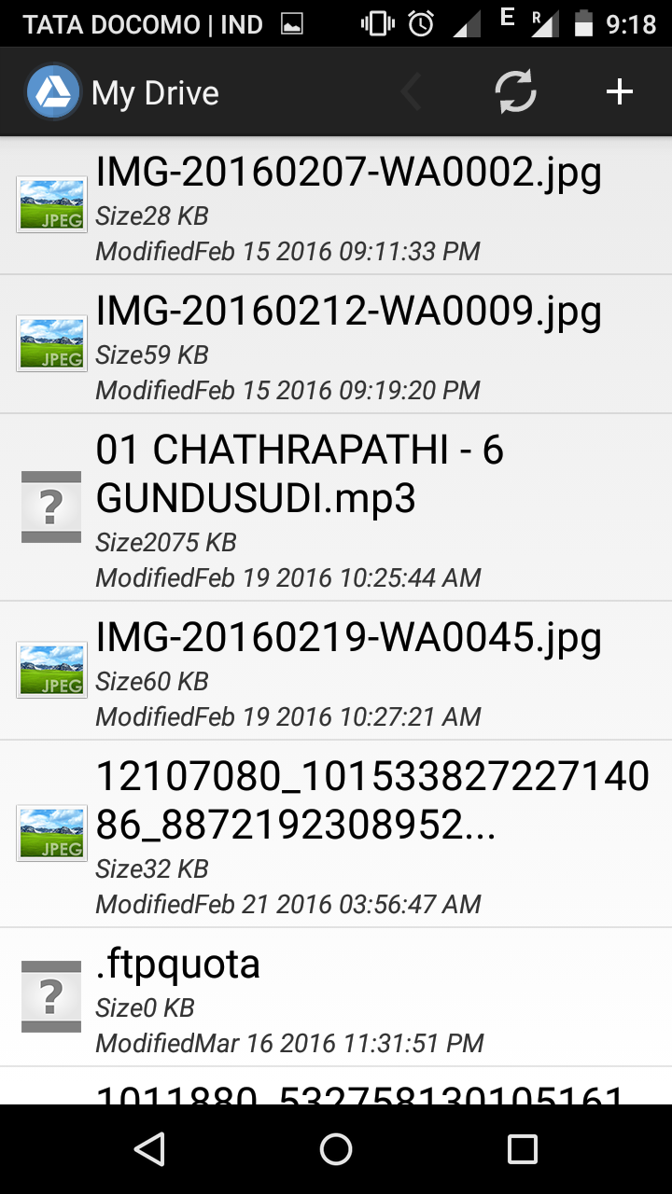
Figure 15: Files View

Fig.16 shows the page where we can upload new files to the cloud.
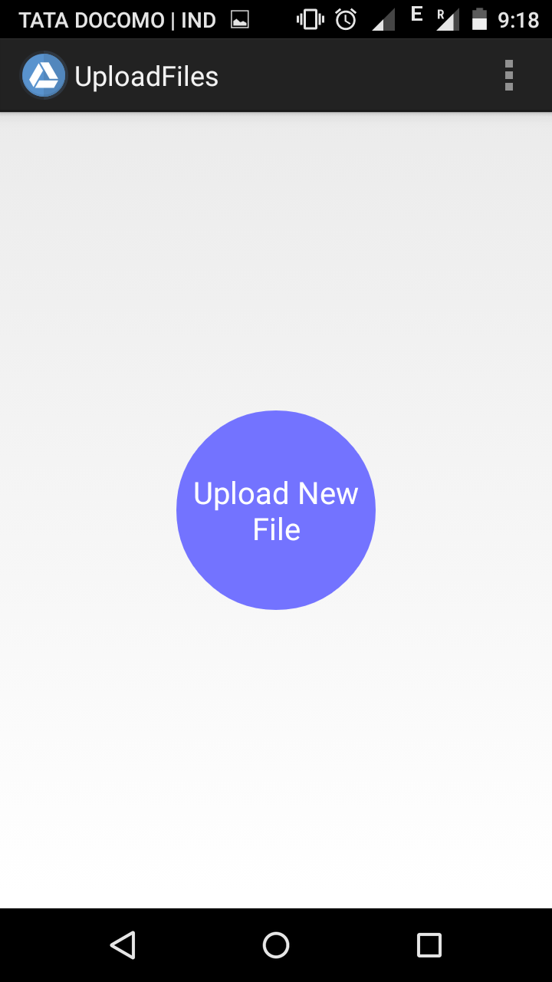
Figure 16: Upload Files

Fig.17 shows the page where user can select any file from his/her device storage.
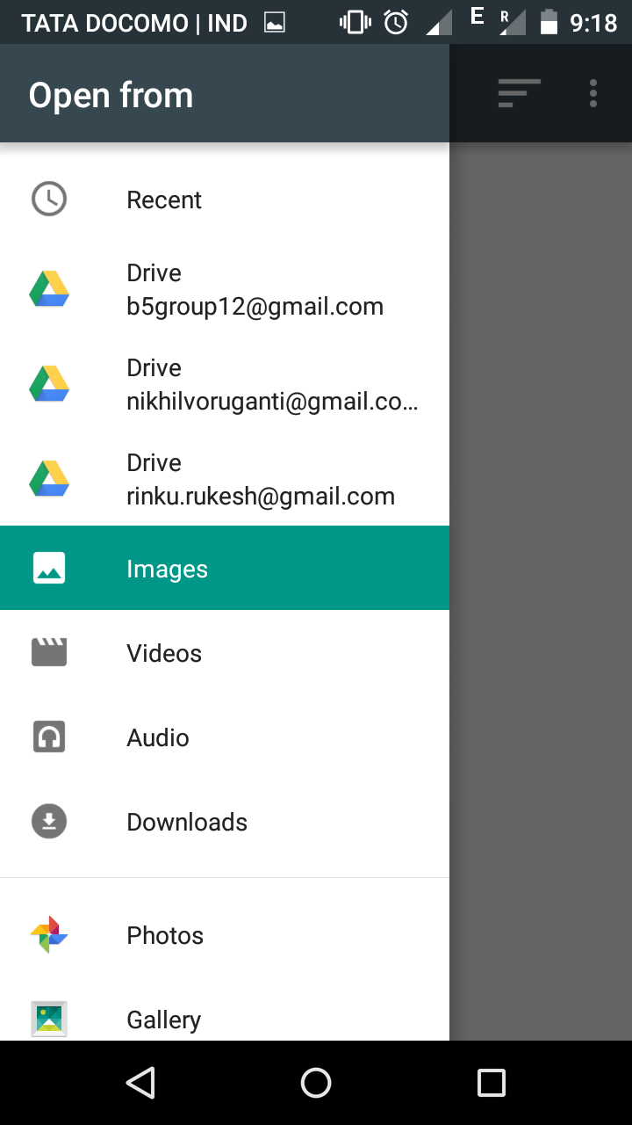
Figure 17: Select Files

Fig.18 shows the Upload completed message when the file is successfully uploaded.
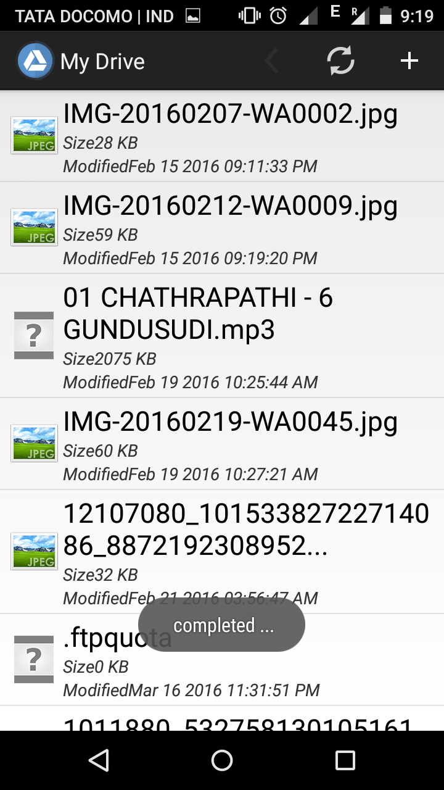
Figure 18: Upload Completed

7. SOFTWARE TESTING
Testing is a process of executing a program with the intent of finding an error. A good test case is one that has a high probability of finding an as-yet –undiscovered error. A successful test is one that uncovers an as-yet- undiscovered error. System testing is the stage of implementation, which is aimed at ensuring that the system works accurately and efficiently as expected before live operation commences. It verifies that the whole set of programs hang together. System testing requires a test consists of several key activities and steps for run program, string, system and is important in adopting a successful new system. This is the last chance to detect and correct errors before the system is installed for user acceptance testing.
The software testing process commences once the program is created and the documentation and related data structures are designed. Software testing is essential for correcting errors. Otherwise the program or the project is not said to be complete. Software testing is the critical element of software quality assurance and represents the ultimate the review of specification design and coding. A good test case design is one that as a probability of finding a yet undiscovered error. A successful test is one that uncovers a yet undiscovered error. Any engineering product can be tested in one of the two ways:
The purpose of testing is to discover errors. Testing is the process of trying to discover every conceivable fault or weakness in a work product. It provides a way to check the functionality of components, sub assemblies, assemblies and/or a finished product It is the process of exercising software with the intent of ensuring that the Software system meets its requirements and user expectations and does not fail in an unacceptable manner. There are various types of test. Each test type addresses a specific testing requirement.

7.1. TYPES OF TESTS
Unit testing:
Unit testing involves the design of test cases that validate that the internal program logic is functioning properly, and that program inputs produce valid outputs. All decision branches and internal code flow should be validated. It is the testing of individual software units of the application .it is done after the completion of an individual unit before integration. This is a structural testing, that relies on knowledge of its construction and is invasive. Unit tests perform basic tests at component level and test a specific business process, application, and/or system configuration. Unit tests ensure that each unique path of a business process performs accurately to the documented specifications and contains clearly defined inputs and expected results.
Integration testing:
Integration tests are designed to test integrated software components to determine if they actually run as one program. Testing is event driven and is more concerned with the basic outcome of screens or fields. Integration tests demonstrate that although the components were individually satisfaction, as shown by successfully unit testing, the combination of components is correct and consistent. Integration testing is specifically aimed at exposing the problems that arise from the combination of components.
Functional test:
Functional tests provide systematic demonstrations that functions tested are available as specified by the business and technical requirements, system documentation, and user manuals.
Functional testing is centered on the following items:
Valid Input : identified classes of valid input must be accepted.
Invalid Input : identified classes of invalid input must be rejected.
Functions : identified functions must be exercised.
Output : identified classes of application outputs must be exercised.
Systems/Procedures: interfacing systems or procedures must be invoked.
Organization and preparation of functional tests is focused on requirements, key functions, or special test cases. In addition, systematic coverage pertaining to identify Business process flows; data fields, predefined processes, and successive processes must be considered for testing. Before functional testing is complete, additional tests are identified and the effective value of current tests is determined.
System Test:
System testing ensures that the entire integrated software system meets requirements. It tests a configuration to ensure known and predictable results. An example of system testing is the configuration oriented system integration test. System testing is based on process descriptions and flows, emphasizing pre-driven process links and integration points.
White Box Testing:
White Box Testing is a testing in which in which the software tester has knowledge of the inner workings, structure and language of the software, or at least its purpose. It is purpose. It is used to test areas that cannot be reached from a black box level.
Black Box Testing:
Black Box Testing is testing the software without any knowledge of the inner workings, structure or language of the module being tested. Black box tests, as most other kinds of tests, must be written from a definitive source document, such as specification or requirements document, such as specification or requirements document. It is a testing in which the software under test is treated, as a black box .you cannot “see” into it. The test provides inputs and responds to outputs without considering how the software works.
UNIT TESTING:
Unit testing is usually conducted as part of a combined code and unit test phase of the software lifecycle, although it is not uncommon for coding and unit testing to be conducted as two distinct phases.
Test strategy and approach
Field testing will be performed manually and functional tests will be written in detail.
Test objectives
- All field entries must work properly.
- Pages must be activated from the identified link.
- The entry screen, messages and responses must not be delayed.

Features to be tested
- Verify that the entries are of the correct format
- No duplicate entries should be allowed
- All links should take the user to the correct page.

INTEGRATION TESTING:
Software integration testing is the incremental integration testing of two or more integrated software components on a single platform to produce failures caused by interface defects.
The task of the integration test is to check that components or software applications, e.g. components in a software system or – one step up – software applications at the company level – interact without error.
Acceptance Testing:
User Acceptance Testing is a critical phase of any project and requires significant participation by the end user. It also ensures that the system meets the functional requirements.

7.2. TEST RESULTS
All the test cases mentioned above passed successfully. No defects encountered.
Test case number | Test case | Input | Expected output | Obtained output
1 | User has to fill all field in sign in page | Give all fields | Login successful | Login successful
Table 1. Signup Page
The above table shows the case where the user is signing in the page. If all the fields are given properly, user has successfully signed in

Test case number | Test case | Input | Expected output | Obtained output
2 | User has to enter his email id as username | Testing | Please enter your mail id | Enter mail id
Table 2.Email Id

In the above case, the user is asked to enter email id. If the user makes any mistake, then the application asks the user to enter email id again as login was unsuccessful.

Test case number | Test case | Input | Expected output | Obtained output
3 | Entering password | Less than 4 characters | Password too short | Password too short
Table 3. Password

In the above case, the user is asked to enter password. If the password is less than 4 characters, the user is requested to enter a valid password.

Test case number | Test case | Input | Expected output | Obtained output
4 | If user enters incorrect password | Login123 | Invalid password | Invalid Password
Table 4. Incorrect Password

The application stores each user content in the database. If the password entered by the user does not match the one in the database, the application returns invalid password

Test case number | Test case | Input | Expected output | Obtained output
5 | If there is no internet connection | Testing | Exception  (MalformedURL exception) | MalformedURL exception
Table 5. No network

The application needs to access the cloud for the user to perform any action. The cloud can be accessed via the internet. If there is no network, the application returns exception.

8. CONCLUSIONS

In this era of multitenant environment emerging complex android application to increases hardware configuration and software solution, there is a high requirement of extensive storage capacity and fast processor for android device which is currently not feasible. Hence the world has to think about other means of distributing the task performed by android device to either system or by some other means which can be accessed through high speed brand band internet through the cloud environment. Cloud provides computational resources that can be used with the help of internet. The usage of cloud for storing the data from android device and performing the task done by android device helps in increasing the computational efficiency of the device. This overcomes the limitation of storage capacity, processor speed and battery life of the android device. The main challenge for storing the data in remote location is the security. The data stored in cloud should be highly secure, so that user does not loose important information. This challenge has been overcome in the system by maintaining a hash table that has the information about several applications and its genuineness. This prevents entry of malicious programs in to the cloud as well as to the android device. A simple trouble shooting required in an operator to validate into thousands of devices access authenticate.
In this project, we have developed an android application where users can store, view and download their files securely. Users will first have to login to application. First time users will have to register by creating an account. Once logged in, they can choose to upload view or download any file. All the files are present in the cloud server. The uploading and downloading of files takes in a secure fashion with the concepts of encryption and decryption. However the user has no idea of the encryption and decryption and cloud methodologies. The user can have access to the application interface and the files in the cloud server.

Best efforts have been put into the project to make it real and user friendly. This application is very unique in its kind, unlike other applications that are existent on the Play Store. This will be highly appreciated and will be handy for any user who face the trouble of managing and maintaining large amount of data. The project "Secure Data Storage and Retrieval from the Cloud" was successfully concluded by meeting the requirements specified by the software requirement document.

REFERENCES

- The Management of Security in Cloud Computing
Ramgovind S, Eloff MM, Smith E
- A Platform Computing Whitepaper, ‘Enterprise Cloud
Computing:Transforming IT’, Platform Computing,
- Data Security and Privacy Protection Issues in Cloud Computing
Deyan Chen1 in 2012 International Conference on Computer Science and Electronics Engineering
- Cloud computing security, http://en.wikipedia.org/wiki/Cloud_
computing_security.
- Integrating Cloud Computing and MobileA Comparative Study Based on Icloud and Applications: Sanscode ; Christian Moss

